

Asia Pacific College

#3 Humabon Place, Magallanes, Makati City 1232

Ph Haunted

**Project Members:**

Carpio, Aira Joyce A.

Gardon, Jana Marie G.

Ferrer, John Kenneth H.

**Course & Section:**  
BSIT MI-141

Engr. Noel Quizon Anonas

***Instructor in Mobile Programming***

Contents

**Chapter 1** 3

**Project Description** 3

**Target Audience and Market** 3

**Related Literature** 3

**Project Objectives** 3

**Scope and Limitations** 4

**Storyline** 4

**Chapter 2** 5

**Mechanics:** 5

**Instructions:** 5

**Cut Scene** 5

**Chapter 3** 6

**Technology used for App Development:** 6

**Diagrams** 6

**Use Case Diagram** 6

**Context Diagram** 6

**Project System Flow Diagram** 7

**Java Code Snippet** 7

**Chapter 4** 11

**Graphic Assets or Artwork Samples** 11

**Chapter 5** 12

**Lessons Learned** 12

**Chapter 6** 13

**Resume of each member** 13

# **Chapter 1**

## **Project Description**

Ph Haunted is a survival horror game that is based on the story of Laperal White House; a haunted house located in Baguio City. It is about jumping to avoid ghost and collecting keys to escape the house. The game will focus on survival of the character.

Ph Haunted is a combination of playing and learning. It also includes a short background story of Laperal White House and how the character of the game entered the story. This game transform common elements from horror fiction into gameplay challenges.

## **Target Audience and Market**

The target audience and Market for Ph Haunted are those people who love survival horror game and mystery. This game is not just a horror game but the people who play this will also enjoy and will learn something.

## **Related Literature**

* Jump Over Box

Jump Over Box is an Obstacle avoidance game. The aim of the player is to avoid box controlling the ball just with the finger and get the best high score. When you press jump - dot jumps up, avoid contact with moving box by jumping over it. The more score you get, smarter box became and it will try to catch you in different way. Tap to jump and last as long as you can. Enjoy!

* Escape Haunted House of Fear

Mystical house with puzzles, hidden objects. Your goal is to find a way to escape this haunted house and save your friend who was kidnapped by monsters. This scary house has monsters, riddles and difficult puzzles. Collect keys to open the door, remember numbers and solve puzzles. Only chance to survive is to find how to escape this scary house full of secrets. The Sequel to the best House of Horror game on Android! Welcome to a world full of nightmares. To finish the game, you will need to collect all items in the rooms.

## **Project Objectives**

The objectives of Haunted PH are the following:

* To know the tragic story and history of Laperal White House
* Enhance user’s strategy
* To learn and have fun at the same time

## **Scope and Limitations**

Ph Haunted is open for everyone unless a particular game sets an age limit. Ph Haunted suits for the audience that are interested in horror and mysteries. This game doesn’t require internet connection to play. Due to lack of time, Ph Haunted is only limited to one location. The user has to survive, as he/she enters to one of the popular haunted houses in the Philippines

## **Storyline**

One of the haunted houses found in the Philippines is Laperal White House, that specifically located in Baguio City. Just like other haunted houses, it remains uninhabited except for the caretaker who lives outside the house within the gates. The tragic story happened when the Laperal family, the oldest clan in Baguio, was brutally murdered inside the house by the Spanish soldiers. The Laperal White House is full of history and unshared stories. Some says that once you enter the house, there is no way to go out.

One night, a guy who loves to travel and explore new things, makes a documentary about the different places in the Philippines. Out of curiosity, he entered the Laperal house. Little did he know that according to the story, no one can escape once they enter the house. The guy was locked inside the haunted house and the only way he can escape is by finding all the keys.

# **Chapter 2**

## **Mechanics:**

You are locked inside the Laperal house at the middle of the night, your main goal is to escape while being attacked by the ghosts. Get all the keys to use as an escape from the house. Each level requires a particular number of keys to finish the level. You must tap the screen to enables the character to jump and you must not touch the ghost to avoid losing your life or the keys you collected. But before you can fully escape the haunted house, you must solve the puzzle. There will be time limit so make sure you rely on your puzzle-solving skills and solve it as fast as you can. Arrange the tiles in their proper position to form the right image while you only have a limited move.

## **Instructions:**

1. To avoid the ghosts, jump over them by tapping the screen.
2. Don’t touch the ghost or else you will lose a life and key you already collected.
3. Collect all the keys, to advance on the next challenge.
4. On the level 4, solve the puzzle as fast as you can by moving the tiles
5. Arrange the tiles in their proper order to form the image properly

## **Cut Scene**

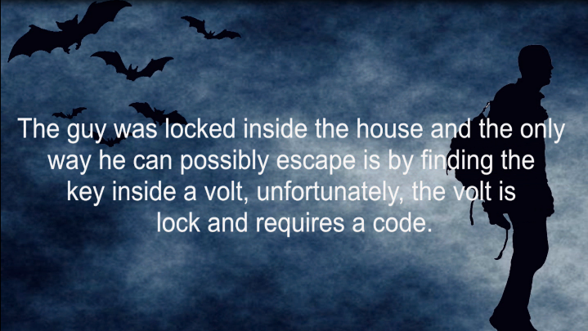

A screenshot from the first part and ending part of the storyboard for level 1. These will show before the game starts. On the storyboard, it will describe how the player had been trapped inside the haunted house. It consists of text in a video format.

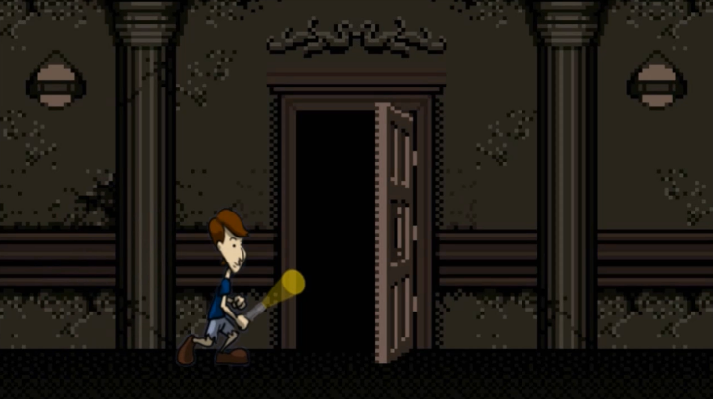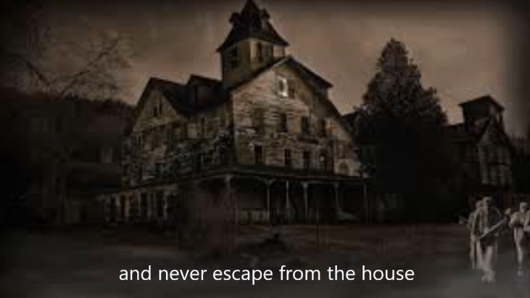

After successfully finishing all the levels, the player can escape the haunted house. The photos above are the end of the storyboard and will show after completed all the levels.

## **Game Map/Levels**

Level 1 (Easy)

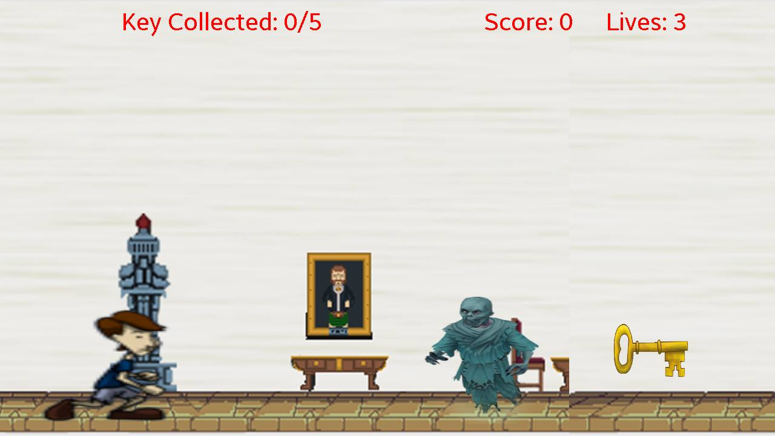

The number on the upper right portion of the screen indicates how many key the user has to get to end the level. While the user collects key, ghost will keep on coming towards him. Avoid the ghost by jumping over them. The player is only limited to 3 lives. Every time the player touches the ghost, one key from his collection will be deducted and will also deduct 5 points in the score.

Level 2 (Medium)

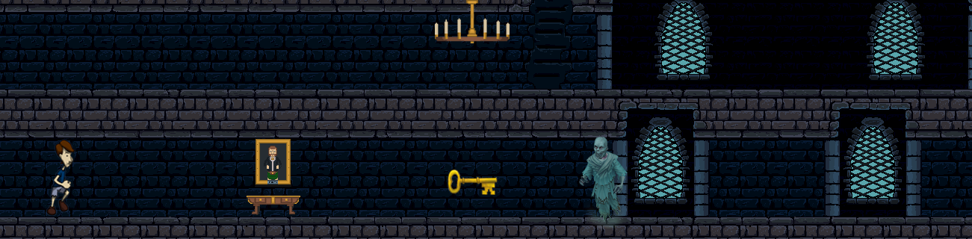

The level 2 automatically starts when the player in the level 1 already collects 5 keys. In this level, the player and ghosts run faster than the first level. Many ghost will appear and requires more keys to collect.

Level 3 (Hard)

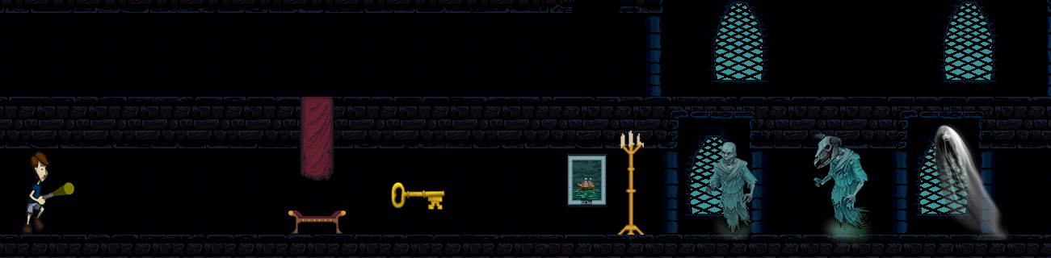

The game is continues until level 3, only when the user successfully collects the keys without losing all his lives. In level 3, the place will be darker, the characters run fastest than the previous level and requires more keys to collect. There are additional ghost characters.

The level 4 or the last level is a puzzle game. The image of the Laperal house was the image to form in the puzzle. The image on the right side and the number in each tile will help the player to determine whether they place the right tile in the right position. There will be move and time limit.

# **Chapter 3**

## **Technology used for App Development:**

* Android Studio
* Adobe Photoshop
* Sony Vegas
* After Effects

## **Screenshot of each page**

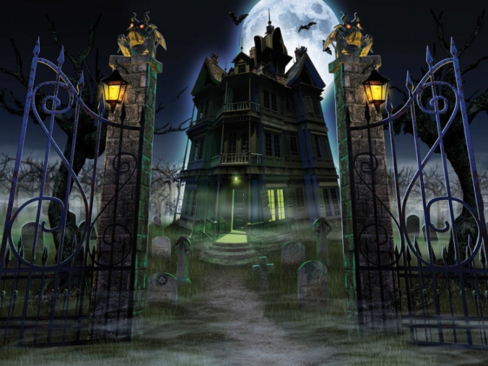

10 seconds splash screen while the image is slowly zoom-in as if the player is walking towards the house.

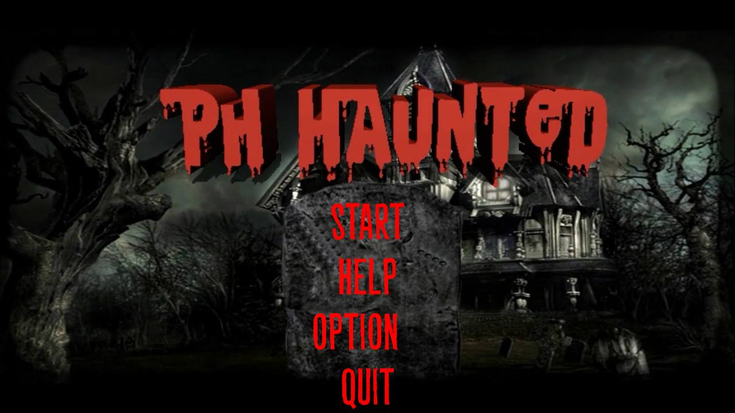

The main screen consists of Start, Help, Option and Quit buttons. The music we used in the main screen is different in the music we used in the splash screen.

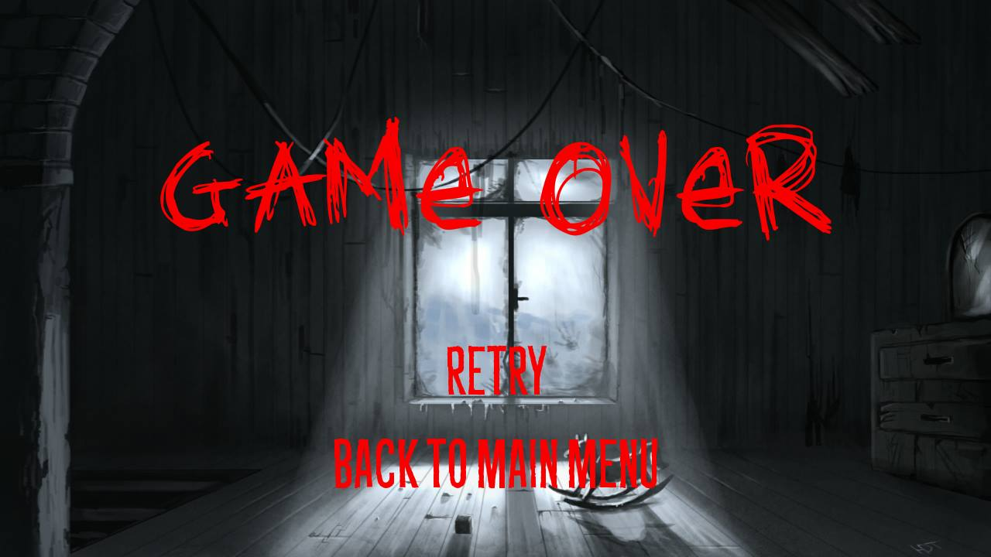

Once the player loss his lives, this Game Over screen will appear. The player has an option to retry the game or go



The start of the storyboard. This will appear first when the user clicks the start button. The game will start automatically when the storyboard ends.



Ph Haunted is consisting of 4 levels; the first 3 levels have the same type of game but it will get harder in each level. The player needs to collect all the keys while jumping over the ghost.

The level 4 is a puzzle game with a moves and time limit. The last game before the player escapes the house.

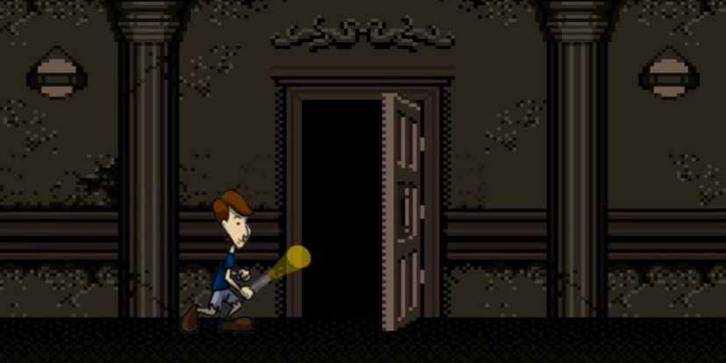This will appear when the player successfully finishes the game. He/she courageously survived being trapped inside the Laperal Haunted House. Congratulations!

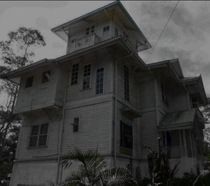

The image in the in the puzzle for level 4

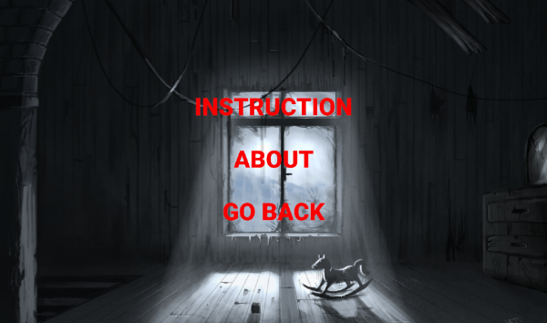

On the Help Screen you will find the Instruction and Mechanics of the game, About the developers and the game,

The Music is located in the Option screen. The user has an option to turn off or on the music

## **Diagrams**

### **Use Case Diagram**

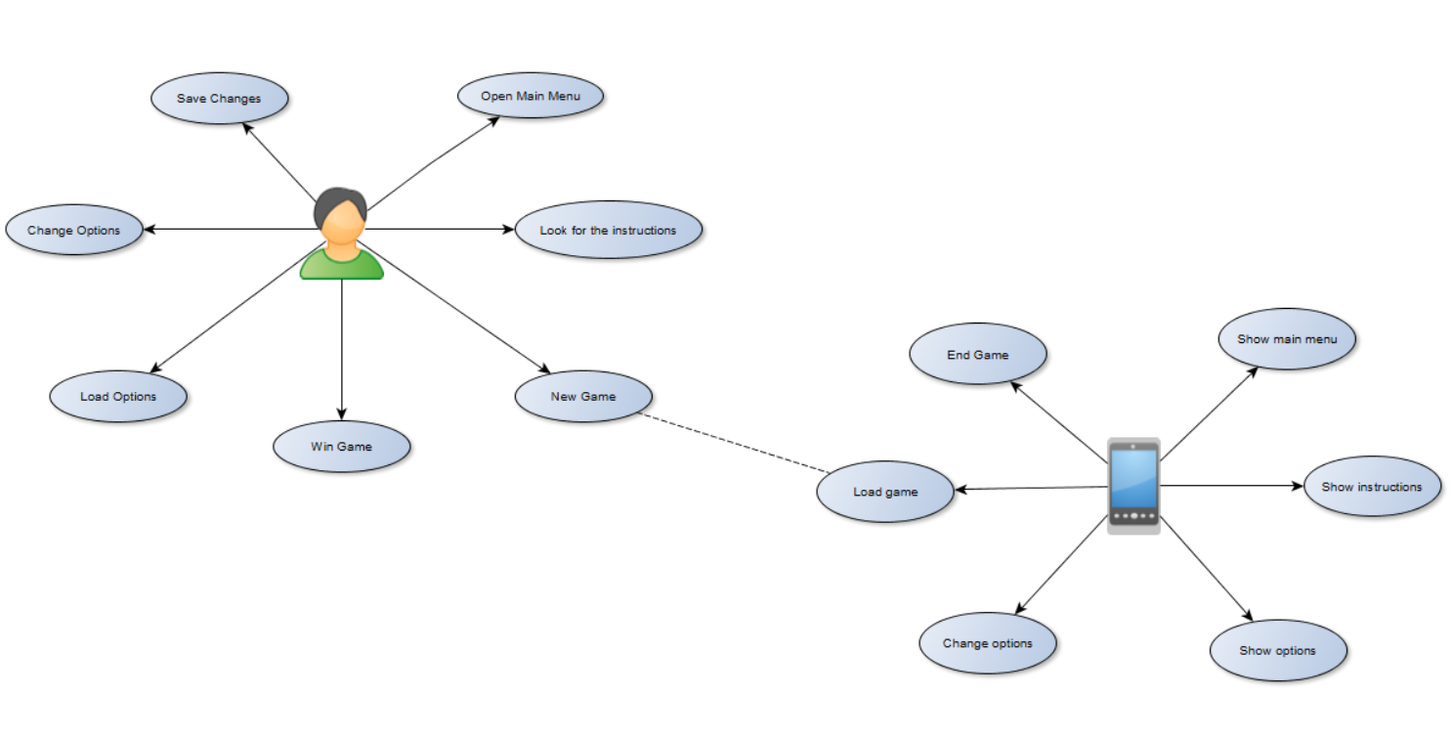

### **Context Diagram**

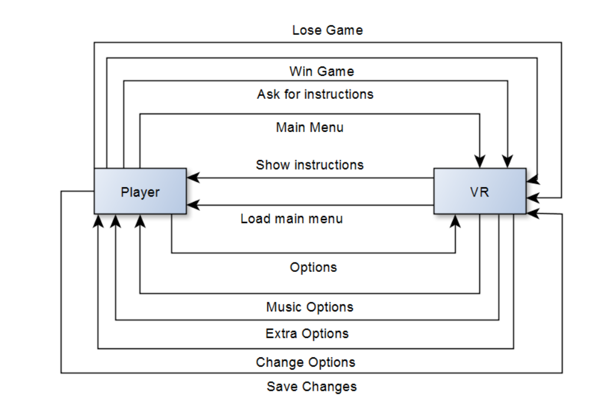

### **Project System Flow Diagram**

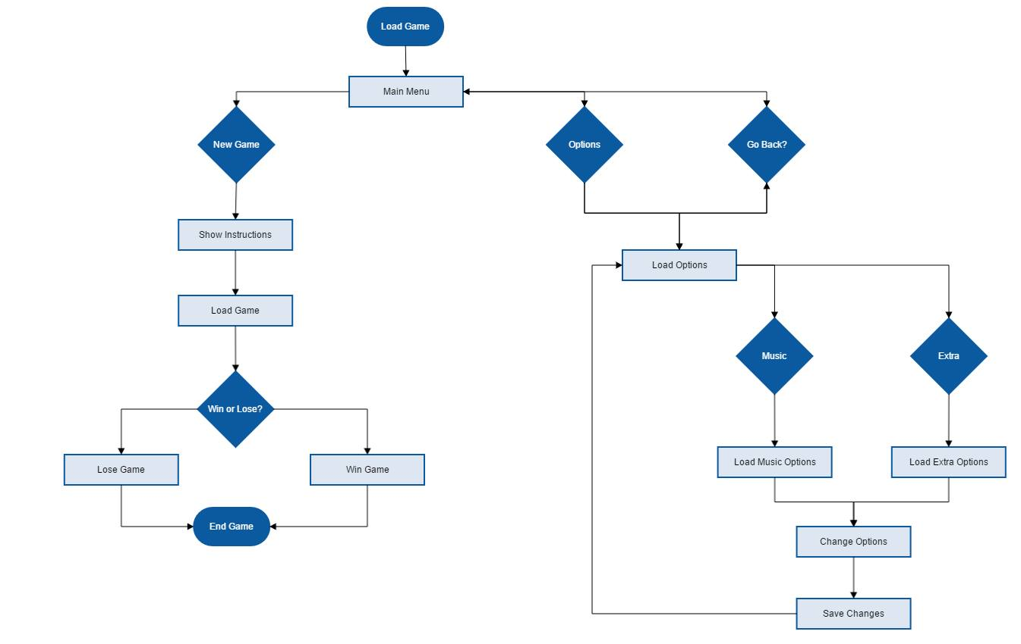

## **Java Code Snippet**

Splash Screen

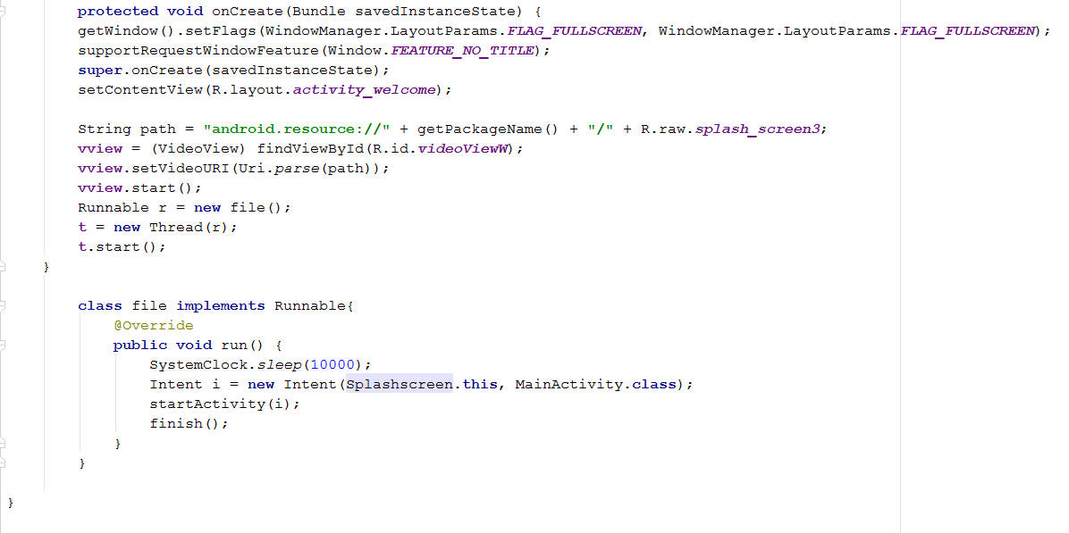

Main Activity

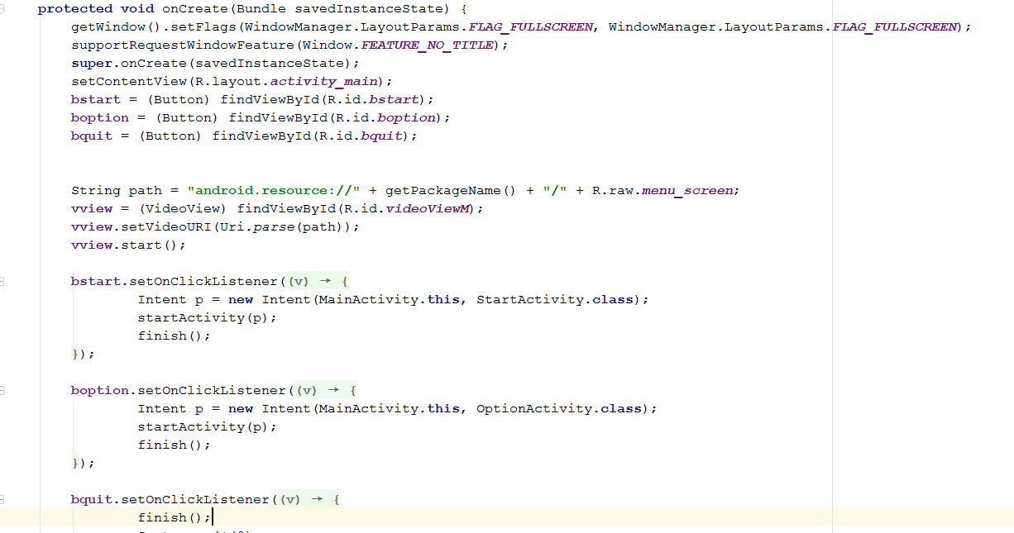

Start Activity

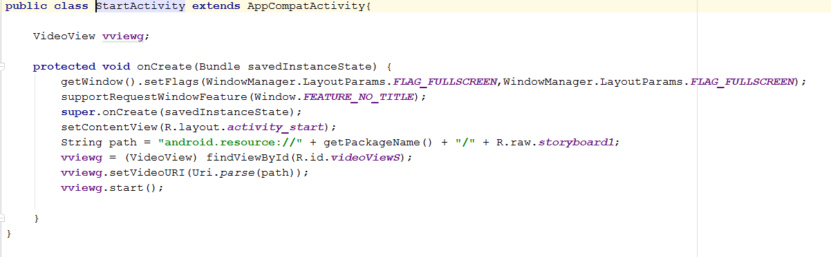

Quit Activity

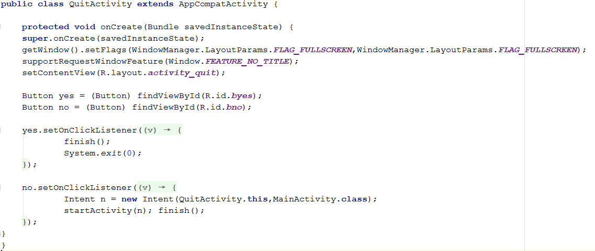

Option Activity

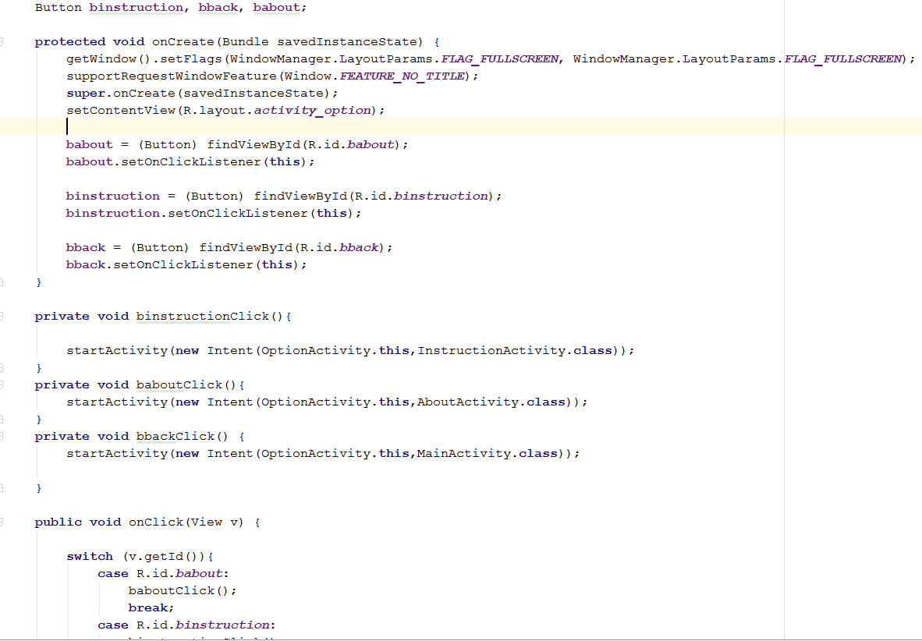

Instruction Activity

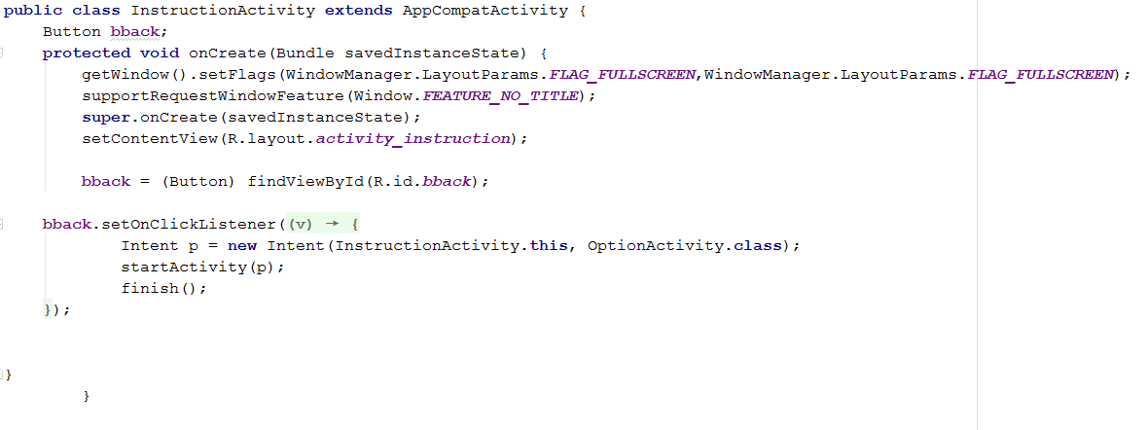

About Activity

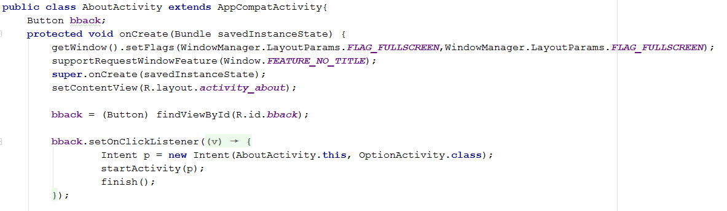

# **Chapter 4**

## **Graphic Assets or Artwork Samples**

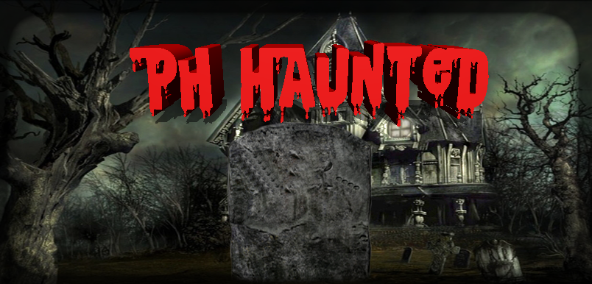The images are the background we used for the Ph Haunted game.

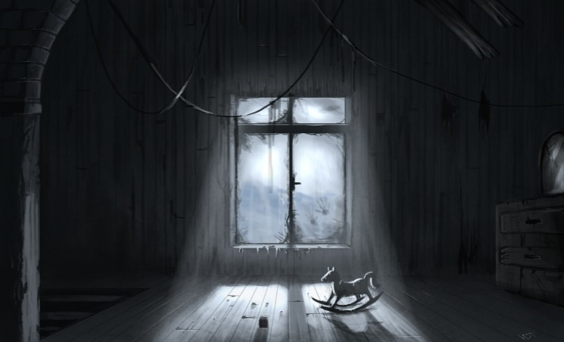For Splash Screen For Main Screen

For the Help and Option, About and Game Over Screen background For the Instruction screen



The background for Storyboard in level 1

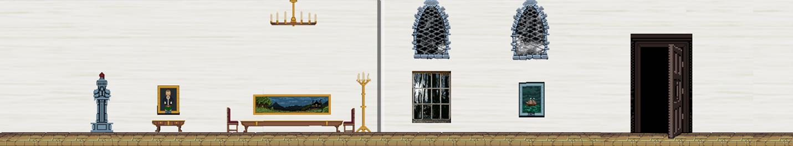

Background for level 1

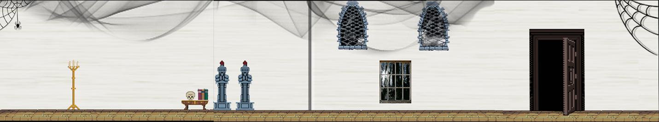

Background for level 2

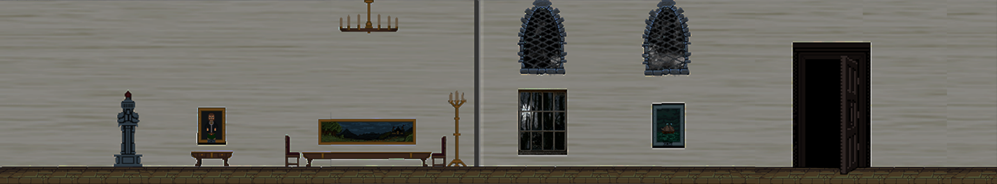

Background for level 3

Spritesheets:



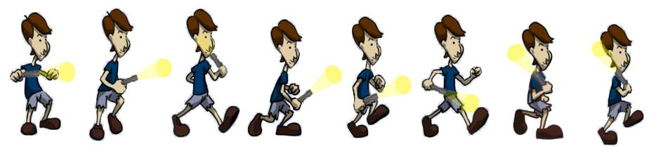

This was used on level 1 The player in level 2 and 3

The only way the player can escape is to find and collects the keys. This is the key we used for the game.

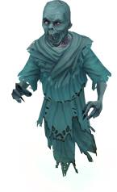

Ghost #1

# **Chapter 5**

## **Lessons Learned**

Creating your own game, sounds interesting and exciting, but for us IT students, in every excitement there is always an equivalent hardship because we know firsthand that it is not easy to build a successful app especially if there is no enough time. A group that has a determination to finish the app and have patience has a chance to build a successful application.

Building this app has been educational. Moving from ideation to coding on a small group, we got a great deal of help from others, and from tools available. Along the way, we discover ideas and codes, we haven’t encountered yet that is a good addition to our knowledge about Java. Of course we’ve taken in a considerable measure about how our accomplices fabricate applications and tackle issues. Though we changed our app from VR to Standard game, at least we know that we can do it, just that we don’t have enough tools and time for it. Moreover, managing our time is the key to avoid cramming.

Players that will use our app, will learn the story behind the Laperal White House and while playing they will enhance their strategy.

# **Chapter 6**

## **Resume of each member**

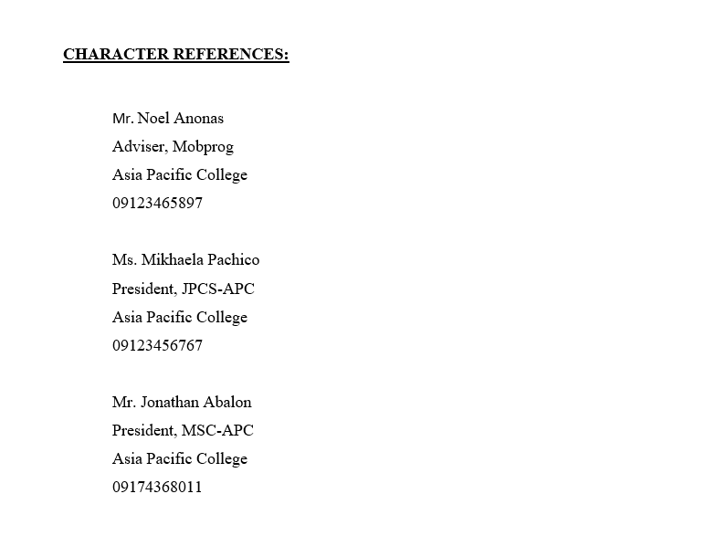 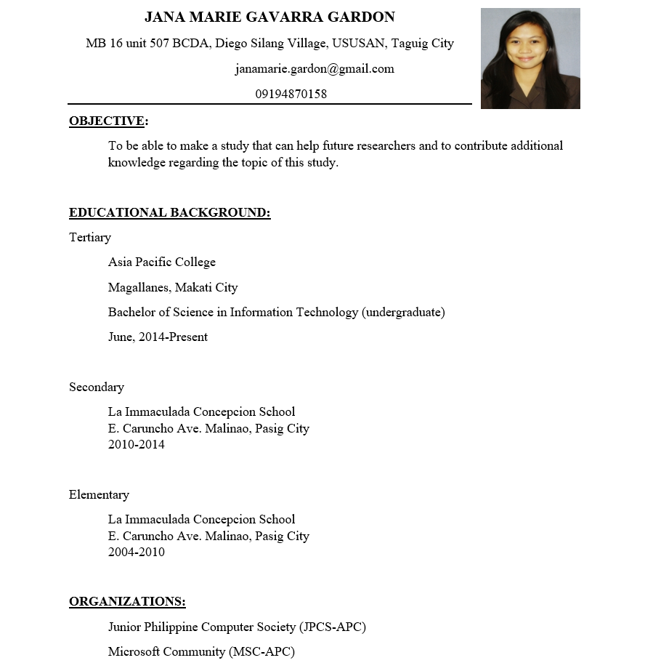

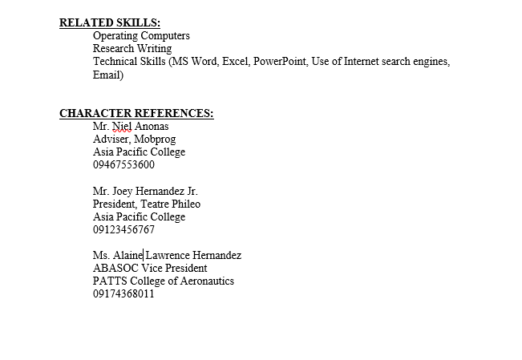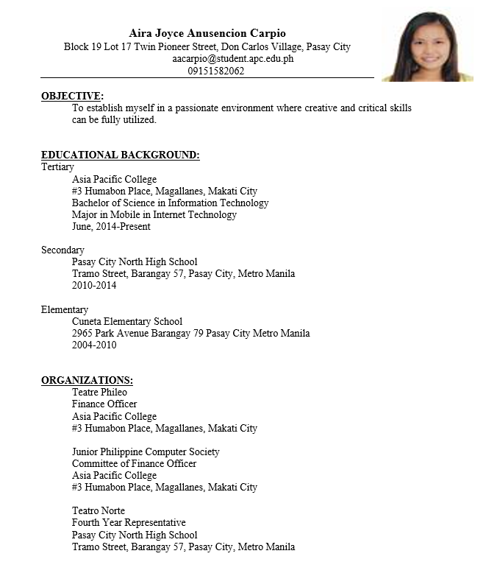

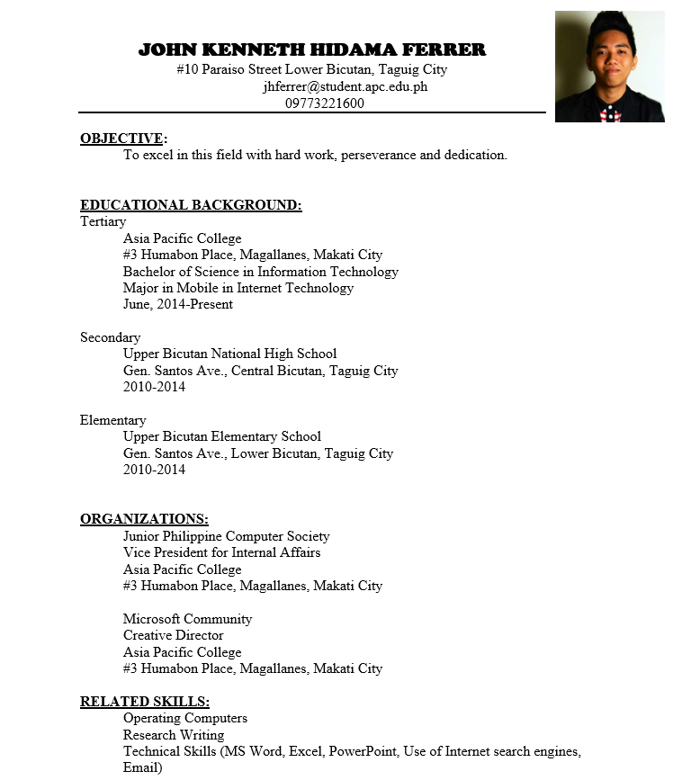

**Work Summary**

|  |  |  |
| --- | --- | --- |
| **NAME** | **ROLES** | **DESCRIPTION** |
| Jana Marie Gardon | Documentation and Programmer | Provide documents for the project and combined all the requirements for the final documentation.  Program the game |
| Aira Joyce Carpio | Lead Programmer | Program the game |
| John Kenneth Ferrer | Designer | Provide the design for the game |

**Revision Page**

|  |  |  |  |
| --- | --- | --- | --- |
| **DATE** | **Version** | **Accomplishment** | **Name** |
| **8/23/16** | V2.1 | Documentation  Music | Jana Marie Gardon |
| **8/23/16** | V2.2 | Game Map/Level  Level 1  Main Screen | Aira Joyce Carpio |
| **8/23/16** | V2.3 | Background | Kenneth Ferrer |
| **9/6/2016** | V3 | Change the Background and spritesheets and add storyboard | John Kenneth Ferrer |
| **9/6/2016** | V3.1 | Add level 4,  and updates level 1,2 and 3 | Aira Joyce Carpio |
| **9/6/2016** | V3.2 | Update documentation and add music | Jana Marie Gardon |